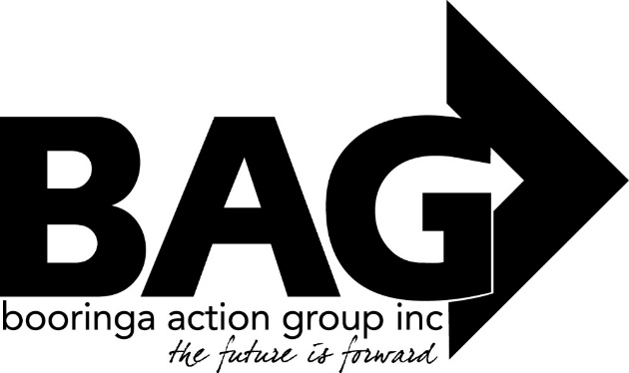
Minutes of the General Meeting of the Booringa Action Group Inc, held at the SPA on Thursday 17th March, 2022 at 5.30pm
Open: Chairman Rob Cornish declared the Meeting open at 5.37pm
Attendance: Mr Rob Cornish chaired the meeting with Jeff Watson, Hazel Wang,Darryl Beitzen,Sandra Cornish,J.Ford,J.Ball,B.Brennan. Cr.Jeff McMullen,Cr John Birkett,CEO Edwina Marks,Kylie Miller,Karen & Stephen Schick in attendance. Rob welcomed everyone to the Meeting.
1.0 Apologies:
Moved H.Wang Seconded J.Ford “That apologies be received and leave of absence be granted for this meeting for Mayor Tyson Golder,Cr.Julie Guthre, Donna McCarrrol.. “ Carried
2.0 Confirmation of Minutes:
Moved J.Watson Seconded D.Beitzen “That the Minutes of the General Meeting held on 17th February, 2022 as circulated, be confirmed” Carried
3.0 Correspondence
Moved J.Watson Seconded S.Cornish “That the Inward Correspondence for the March 2022 meeting be received “ Carried.
4.0 Financial Report
Moved J. Watson Seconded J.Ball “That the Financial Report for the March 2022 meeting be received subject to audit”. Carried
4.1 List of Payments
Moved J. Watson Seconded J.Ford “That the List of Payments for February 2022, as contained in the Financial Report be approved”. Carried

5.0 Officers Report
Moved J. Watson Seconded S.Cornish “That the Officers Report for the March 2022 Meeting be received.“ . Carried
A Verbal Report will be presented
6.0 General Business
Friends of the Gallery:
J.Ford gave a report and advised that the Year ahead is progressing well and there will be a Work Shop for any interested Artists on the 2nd April, 2022.
Moved J.Ford Seconded D.Beitzen “That BAG investigate the possibility of installing a Charging Hub Station” Carried

Next Meeting: The next meeting will be held on Thursday 21st April, 2022, at the Spa, unless otherwise notified.
Close: No further business, President Rob closed the Meeting at 6.46 pm and thanked everyone for their attendance and input
President……………………………… Date……………………………….

