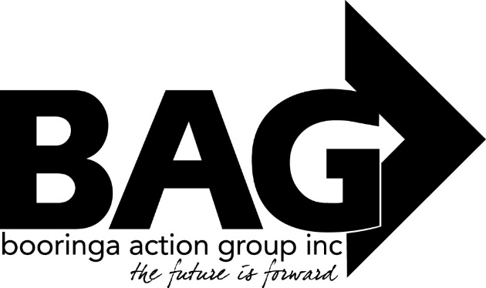
Minutes of the Annual General Meeting of the Booringa Action Group Inc, held at the Cottage on Thursday 25 November 2021 at 5.30pm
Open: Chairman Rob Cornish declared the Meeting open at 5.30pm
Attendance: Mr Rob Cornish chaired the meeting with Jeff Watson, John Ford, Sandra Cornish, Darryl Betzien, Ross Halpin, Hazel.Wang, J.Ball, J.Fenton, B.Stanton, B.Brennan, K.Blackett, R.Kirkman, Mayor T.Golder, Cr J.Birkett and Director Norm Garsden in attendance. Rob welcomed everyone to the Meeting.
- Apologies:
Moved S.Cornish Seconded H.Wang
“That apologies be received and leave of absence be granted for this meeting for Donna McCarrol, Dee Schafer, Crs Geoff McMullen & J.Guthrie.
Carried 16/0
- Confirmation of Minutes
Moved J.Fenton Seconded J.Watson
“That the Minutes of the Annual General Meeting of the Booringa Action Group Inc. held on 22nd October 2020, as circulated, be confirmed”
Carried 16/0
- Presidents Report
The President’s Report for the 2020/2021 Year is attached
Moved J.Fenton Seconded R.Halpin
“That the Presidents Report for 2020/21 be adopted”
Carried 16/0
4.0 Adoption of Financial Statements
Moved Jeff Watson Seconded K.Blackett
“That the Audited Financial statements for 2020/21 be adopted”
Carried 16/0
- Auditors Report
Moved J. Watson Seconded K.Blacket
“That the Auditors Report for the 2020/21 Year be adopted”
Carried 16/0
- Election of the Management Committee
All positions on the Management Committee are declared vacant. BAG’s Constitution requires that the Management Committee be comprised of a minimum of 5 persons including the President and Treasurer.
Mr John Ford was Nominated By: B.Brennan Seconded By: D.Betizen
The Nomination was accepted and Mr. John Ford was declared elected.
Mr Jayden Ball was Nominated By: J.Watson Seconded By: S.Cornish
The Nomination was accepted and Mr Jayden Ball was declared elected.
Mr.Darryl Betizen was Nominated By: Jeff Watson Seconded By: K.Blackett The Nomination was accepted and Mr Darryl Betizen was declared elected.
Mrs. Kerrol Blackett was Nominated By: Jeff Watson Seconded By: Jayden Ball The Nomination was accepted and Mrs. Kerrol Blackett was declared elected.
There being no further nominations, the election of Management Committee members was concluded and accepted by acclamation.
- Appointment of Auditor
Moved Jeff Watson Seconded J.Ford “That Mrs Belinda Hayward be appointed Auditor for the 2021/22 Financial Year”
Carried 16/0
9.0 Closure
The business of the 2021 Annual General Meeting being concluded, the President thanked all for their efforts, their attendance and accepting positions and declared the Meeting closed at 5.58pm.
President …………………………………. Date …………………………….

