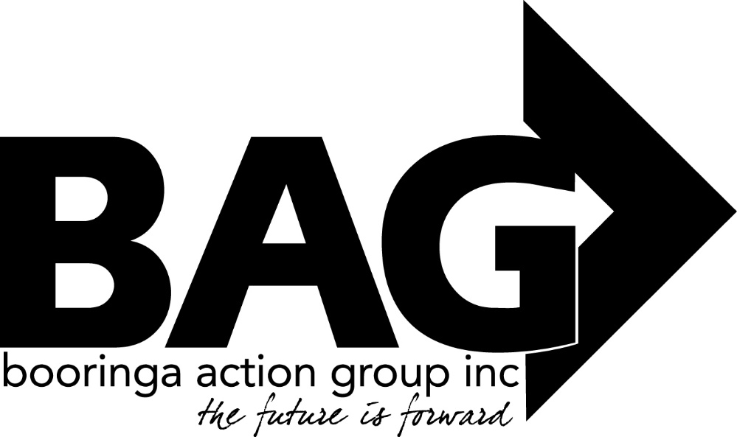

Minutes of the General Meeting of the Booringa Action Group Inc. held at the Shire Hall on Thursday July 21, 2022 commencing at 5.30 P.M.
Attendance Mr Rob Cornish chaired the meeting with Jeff Watson, Sandra Cornish, Barbara Brennan, Donna McCarrol, Darryl Betzien, Ross Halpin, Hazel Wang, Seamus Batstone, Kylie Millar, Lyndon Kirkpatrick, Jane Fenton, Bernadette Stanton and Cr John Birkett
Apologies
Moved S. Cornish Seconded B. Stanton
“That apologies be received and leave of absence be granted for this meeting for John Ford, Mayor Tyson Golder, Crs Geoff McMullen Julie Guthrie, Mark Edwards, George Ladbrook, Cameron O’Neill, Wendy Taylor and Jo Hancock.”
Carried 12/0
2.0 Confirmation of Minutes
Moved H. Wang Seconded B. Brennan
“That the minutes of the General Meeting held on 16 June 2022 as circulated be confirmed”
Carried 12/0
- Correspondence
Inwards:
Jane Cornish: Submitting her resignation as Editor of the Bottle Tree Bulletin and thanking BAG for the opportunity to carry out this role for the last six years. Jane’s resignation becomes effective on August 1 and she offers her help with training a new editor to ensure a smooth transition.
Outwards:
University of Southern Queensland:
Expressing BAG’s interest in having an outreach campus or satellite study centre established in Mitchell and asking if USQ would be interested in opening discussions towards this goal.
Some discussion was held as to where this campus could be situated at least until the Ken Hobson building is finished with the BAG office and the old Council library being mentioned (subject to Council needs and wishes). Lyndon offered to sponsor a container for storage space should the old library be a possibility

Moved J. Watson Seconded B. Stanton
“That the Inwards Correspondence be received and the Outwards correspondence be endorsed.”
Carried 12/0
4.0 Financial Report
Moved J. Watson Seconded R. Halpin
”That the Financial Report for the July 2022 meeting be received subject to audit”
Carried 12/0
4.1 List of Payments
Moved J. Watson Seconded B. Brennan
“That the List of Payments for June 2022 as contained in the Financial Report be approved”
Carried 12/0
- Officers Report
Jeff presented his Officers Report to the meeting.
Spa visitation has increased considerably since commencing operations. Total since that date is 177,677.
Shade Shelter – Tourism Precinct: As reported at previous meetings, BAG has received a Sunsmart Grant to construct a shade shelter at the Tourism Precinct. The shade is now complete.
Water Temperature – Hot Pool: Since last meeting the hot pool temperature declined to a point where it was felt necessary to reduce admission prices by 50%. Fortunately, the additional heating unit which Council had on order arrived on July 12 and was installed by Council on July 13. Council’s urgency and assistance with this problem was invaluable and formal thanks were sent to Edwina, Seamus, Council and staff for their help in quickly resolving this issue.
Bottle Tree Bulletin – Jane Cornish has resigned as editor of the Bottle Tree Bulletin. Moving forward, Ashley Tate will take over this role and it will be written into the normal fortnightly roster.

Drought Resilience Leaders Development Program – Bree and Dee (Schafer) have completed their rural leadership courses. The five participants in this region (Mitchell 2, Roma 1, Morven 1 and Bollon 1) have applied to pool the funds available to them under the terms of the Program to conduct a series of community resilience workshops in Mitchell, Morven and Bollon. BAG has volunteered to cover the catering costs for the Mitchell Workshop so that sufficient funds exist to cover the catering in the two smaller towns.
Covid Leave – With Covid enjoying a new lease of life, business generally is experiencing difficulty in keeping staff at work. There has been some discussion of the fact that some people are not bothering to self test thinking it’s the flu or not wanting to lose a weeks’ pay (especially for casuals). BAG was asked to consider making staff the following offer should they test positive:
- Payment of their rostered hours for the 7 days they are off work or,
- A lump sum payment of $500, whichever is the lowest
- Neither provision to apply should they choose to pursue the $750 (if and when it is available)
Moved B. Stanton Seconded Hazel Wang
“That BAG adopt the above staff offer”
Carried 12/0
General Maintenance – Director Seamus has given BAG the opportunity to show him around the spa and outline our long term vision for its continued growth and development.
Moved J. Watson Seconded D. Betzien
“That the Officers Report for the July 2022 meeting be received”
Carried 12/0
General Business
Friends of the Gallery Report:
In Johns’ absence Jane gave a brief report mentioning:
- A flying arts meeting will be held on 27th July,
- RADF upcycling project has been approved,
- there is a button display on Saturday, and
- 8 passengers are required to take a bus to Roma for Joan Hurtados’ exhibition. Thank you, Jane.
Head Space requires a room for counselling appointments, 1 day per fortnight. Jeff suggested the BAG Office or the treatment room at the hall could be used for these sessions.

Christmas in the Park:
The Meeting resolved to hold Xmas in the Park on Friday December 2 subject to Rotary’s agreement noting that this would be the first staging of the event in the newly redeveloped Park.
St Patricks Tennis Courts - Kylie Miller advised that the tennis courts proposal looks promising but she is yet to find out what can be done about securing long term community access to the courts. She thanked BAG for their support.
Next Meeting: The date of the next meeting will be August 18 unless otherwise advised.
Closure: There being no further business the Chairman closed the meeting at 7.07pm and thanked all for their attendance.

Chairman……………………………. Date……………………………..

