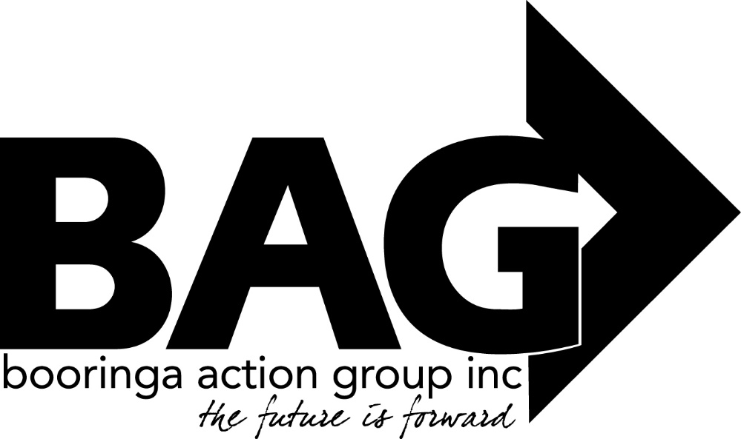

Minutes of the General Meeting of the Booringa Action Group Inc. held at the Great Artesian Spa on Thursday February 17 2022 commencing at 5.45 P.M.
Attendance Mr Rob Cornish chaired the meeting with Jeff Watson, Sandra Cornish, Darryl Betzien, Donna McCarrol, John Ford, Cr Julie Guthrie, Ross Guthrie, Cr John Birkett, Cr Geoff McMullen, Ross Halpin, Bernadette Stanton, Hazel Wang, Kylie Miller, Bree Jiggins, Sharon (SS Headmistress), Richard Kirkman and Norm Garside.
Apologies
Moved B. Jiggins Seconded J. Ford “That apologies be received and leave of absence be granted for this meeting for Mayor Tyson Golder, Cr George Ladbrook, Barbara Brennan, Edwina Marks, J. Fenton and J. Ball
Carried 11/0
Confirmation of Minutes
Moved R. Halpin Seconded H. Wang “That the minutes of the General Meeting of the Booringa Action Group Inc. held on 25 November 2021, as circulated be confirmed”
Carried 11/0
Correspondence :
Inwards Correspondence: Hon David Littleproud MP
Advising that BAG’s Expression of Interest for funding under the coalition Governments stronger Communities Programme (SCP) round 7 was not successful.
Richman Kirkman Expressing his interest in leasing the Sleeping Car currently at the Mitchell Railway Station.
Moved J. Watson Seconded R. Halpin “That the inward correspondence for the February 2022 meeting be received”
Carried 11/0
Outwards Correspondence: Letters of support
A letter in support of a Funding Applications has been provided to
- Mitchell RSL – Community Benefit Fund Major Grants - RSL Hall Upgrade Moved J. Watson Seconded R. Kirkman “That the Outwards Correspondence for the February 2022 meeting be endorsed”

Carried 11/0
Financial Report
Moved J. Watson Seconded B. Stanton “That the Financial Report for the February 2022 meeting be received subject to audit”
Carried 11/0
List of Payments
Moved J. Watson Seconded S. Cornish “That the List of Payments for September 2021 as contained in the Financial Report be approved”
Carried 11/0
Officers Report
Jeff and Bree presented the Officers Report, Tourism visitation has been significantly less than in the past, although the $ value is higher. The Spa pools will be closed from 8 March until 19 March while maintenance work is carried out. The Café, Gym and Visitor Centre will remain open during this time.
Christmas in the Park proved to be a really good night, profit was up by 55%. Anyone with grievances or suggestions on improving the night are encouraged to talk with BAG Management personnel. More entertainment for children is one suggestion received so far. A letter of thanks to go to Roma Rotary fellows who came to help on the night.
Kenniff Capture Dinner
Jeff advised that a dinner was being planned for June 23 to commemorate the capture of the Kenniff brothers 120 years ago on that date. He continued that, as part of the Fire and Water Festival theme, it would be the “Grazing on the Maranoa” event for 2022. Mr Mike Munro, well known TV reporter and personality (and a descendant of the Kenniff brothers) had accepted an invitation to be the guest speaker on the night. As ticket sales would be capped at 120 he suggested that an application be made to the Maranoa Regional Council’s Community Grants Scheme be made to ensure the financial outcome was at least neutral.
Moved H Wang Seconded R. Halpin “That BAG submit an application for financial assistance towards the Kenniff Capture Dinner to the Maranoa Regional Council’s Community Grants Scheme”
Carried 11/0

General Business: Friends of the Gallery John Ford presented his report for the Gallery. John reported that a Regional Group has been formed, it is hoped this is a positive move for the Mitchell Gallery. John thanked BAG for providing a secretary for the Group and also a chairman for Mondays’ meeting. Chairman Rob thanked John for his report.
Bus: Moved J. Ford Seconded H. Wang
“That negotiations and purchase of the bus be left in the hands of Jeff, Ross and Darryl”
Carried 11/0
Next Meeting: The next meeting will be held on Thursday March 17, 2022 unless otherwise notified.
Closure: There being no further business the Chairman closed the meeting at 6.56pm and thanked all for their attendance, especially the Councillors Julie Guthrie, John Birkett, Geoff McMullen and both the schools’ principals.

