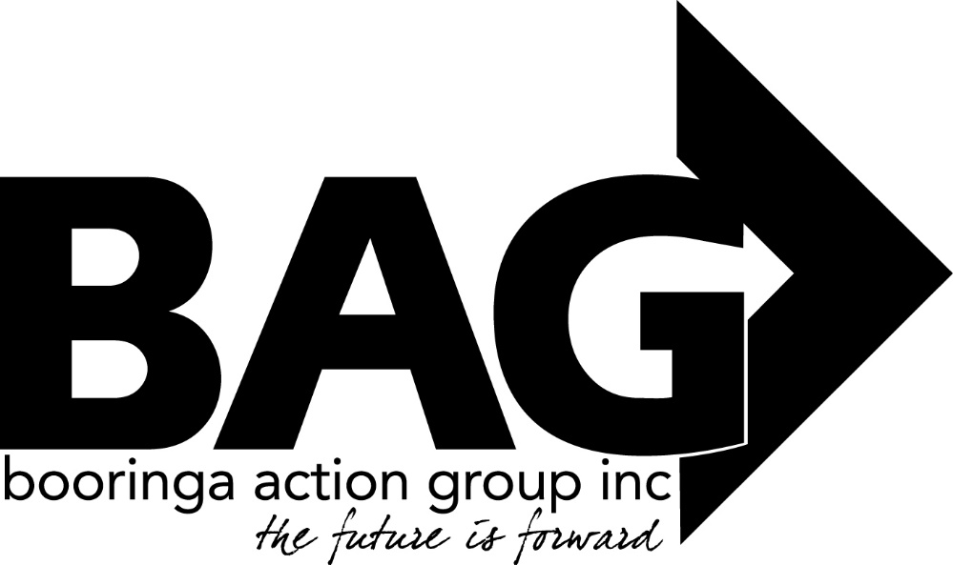

Minutes of the General Meeting of the Booringa Action Group Inc. held at the BAG Cottage on Thursday October 21, 2021 commencing at 5.30 P.M.
Attendance Mr Rob Cornish chaired the meeting with Jeff Watson, Rob and Sandra Cornish, Darryl Betzien, Barbara Brennan, Donna McCarrol, Darryl Betzien, John Ford, Cr Julie Guthrie, Ross Guthrie, Cr John Birkett, Cr Geoff McMullen and Norm Garside
Apologies
Moved D. Betzien Seconded B. Brennan “That apologies be received and leave of absence be granted for this meeting for Mayor Tyson Golder, Hazel Wang, and Ross Halpin Carried 8/0
Confirmation of Minutes
Moved D. Betzien Seconded S. Cornish “That the minutes of the General Meeting of the Booringa Action Group Inc. held on 9 September, 2021 as circulated be confirmed” Carried 8/0
Correspondence : Inwards Correspondence
Maranoa Regional Council
Advising that: As part of the Capital works budget for 2021/22, Council has included funding for an Ash Wall at the Mitchell Cemetery. Council wishes to involve the community in the decisions regarding placement, style and name for the wall.
Council also requests consideration of a preferred name for the wall. “Wall of Memory” or “Wall of Remembrance” have been chosen in some communities, whereas other communities around Maranoa use the term “Columbarium” or “Ash Wall”.
At this stage it is hoped construction will start in early 2022.
Maranoa Regional Council
Advising that at its special Meeting held August 18, Council received BAG’s letter of request in relation to concerns regarding the continued presence of NAB and subsequently resolved to have a further report prepared for an upcoming General Meeting.
Outwards Correspondence
Maranoa Regional Council
Seeking Councils permission to hold Xmas in the Park on December 6 and it’s consideration of once again providing the usual in kind assistance.
Letters of Support
- Booringa Heritage Museum
- Mungallala Progress and Sporting Association
- Maranoa Regional council – Fish Infrastructure Grant
- Mitchell Camp draft
Moved J. Watson Seconded J. Ford “That the Outwards Correspondence for the September/October 2021 meeting be endorsed” Carried 8/0
Financial Report
Moved J. Watson Seconded B. Brennan “That the Financial Report for the October 2021 meeting be received subject to audit” Carried 8/0
List of Payments
Moved J. Watson Seconded S. Cornish “That the List of Payments for September 2021 as contained in the Financial Report be approved” Carried 8/0
Officers Report Jeff presented his Officers Report to the meeting.
In keeping with the Managements Agreement with council, the Spa will be open until 7pm on Tuesday and Thursday nights. To make good use of this extra time, there will be Wine and Cheese evenings on the Deck from 5.30 – 7.00pm on these nights, cost is $20.00 per person, a complimentary glass of wine will be provided. Since the new coffee machines’ instalment on the deck, sales of coffee have risen by 35%.
The Spa having been nominated in three categories at the Maranoa Business Awards – Tourism and Hospitality Business of the Year, Medium Business of the Year and Business of the Year resulted in Jeff and Hazel travelling to Roma to represent the Great Artesian Spa. The trip was made very worthwhile when they were presented with the Best Medium Business of the Year Award, the Tourism and Hospitality Award and were a finalist in the Best Business Award. Congratulations to all concerned! A wonderful achievement!
Moved J. Watson Seconded J. Ford “that the Officers Report for the October 2021 meeting be received.” Carried 8/0
Chairman Rob thanked Jeff, Bree and all the Spa staff for their outstanding work in achieving these awards. He also praised the involvement of the bus drivers, trip advisor and Western Experience for their part in the Spa’s huge increase in visitor numbers.
General Business: Friends of the Gallery John Ford presented his report for the Gallery. A couple of outstanding displays have been on show recently with more to come before Christmas. John expressed concern at the poor state of the relationship between the Woodalls’ and BAG and hopes this can be rectified in the near future. Chairman Rob thanked John for his report.
Rob introduced Norm Garside to the Group, Norm is the new Director – Booringa Directorate for the Maranoa Regional Council in Mitchell.
Wall of Remembrance: Photos were presented to the Meeting of Remembrance Walls in Wallumbilla, Surat and Injune. A consultation meeting will be held at the Cemetery to discuss brick colour and placement of the Wall.
Ken Hobson Building: Concerns were expressed at the direction the consultation meeting took in relation to the library being moved.
Moved B. Brennan Seconded J. Ford “that a letter be sent to MRC expressing concerns at the way the last consultation meeting was conducted and stating that the original plan should be adhered to and decided on.” Carried 8/0
Organisational Restructure: Jeff expressed his concerns that he is the only person able to contact and deal with the ATO through My Gov. He suggested a new business mobile phone be purchased and that Bree be moved up and for her to able to deal with ATO and any My Gov concerns.
Moved D. Betzien Seconded S. Cornish “that the Group approve the organisational restructure” Carried 8/0
Mitchell Dump: The Meeting resolved to write to Norm to have the opening hours at the dump clarified.
Christmas in the Park this year will be on Monday 6th December.
Guest Speaker Moved J. Ford Seconded D. Betzien “that a guest speaker be invited to future BAG meetings” Carried 8/0
Next Meeting The next meeting will be held on Thursday November 25, 2021 unless otherwise notified. It is expected that the AGM will be held on the same day. Closure There being no further business the Chairman closed the meeting at 7.25pm and thanked all for their attendance.

Chairman……………………………. Date……………………………..

