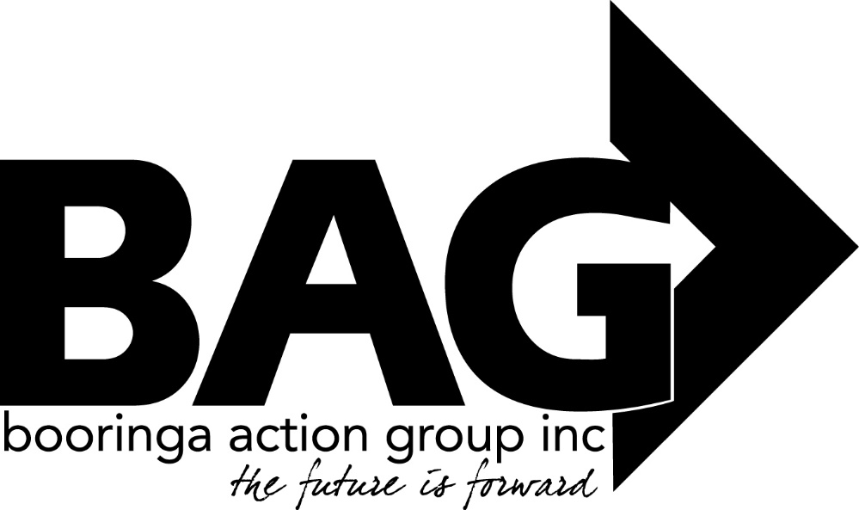

Minutes of the General Meeting of the Booringa Action Group Inc. held at Mitchell Shire Hall on Thursday May 19 2022 commencing at 5.30 P.M.
Attendance Mr Rob Cornish chaired the meeting with Jeff Watson, Rob and Sandra Cornish, Barbara Brennan, Donna McCarrol, John Ford, Ross Halpin, Jayden Ball, Jane Fenton, Dean Elwood, Cr Geoff McMullen, Bernadette Stanton, Dee Schafer and Craig Hilly in attendance
- Apologies
Moved B. Stanton Seconded B. Brennan
“That apologies be received and leave of absence be granted for this meeting for Mayor Tyson Golder, Crs John Birkett, Julie Guthrie, Mark Edwards, George Ladbrook, Cameron O’Neill, Wendy Taylor, Jo Hancock, M/s Kylie Miller, Darryl Betzien”
Carried 14/0
2.0 Confirmation of Minutes
Moved J. Ball Seconded D. Schafer
“That the minutes of the General Meeting of the Booringa Action Group Inc. held on April 21, 2022 as circulated be confirmed”
Carried 14/0
- Correspondence
Inwards Correspondence: No Inwards correspondence for this meeting
Outwards Correspondence: Maranoa Regional Council
Seeking Council’s consideration of carrying forward the $11000.00 budget allocation for reproduction of the old Bridge Artworks into the 2022-23 budget to allow time for the project to be re-scoped of additional funds sourced.
“That the Outwards Correspondence for the May 2022 meeting be endorsed”
Carried 14/0

- Financial Report
Moved J. Watson Seconded J. Ford “That the Financial Report for the May 2022 meeting be received subject to audit”
Carried 14/0
4.1 List of Payments
Moved J. Watson Seconded B. Brennan “That the List of Payments for April 2022 as contained in the Financial Report be approved”
Carried 14/0
- Officers Report
Jeff presented his Officers Report to the meeting. Total visitation since commencing operations at the Great Artesian spa in October 2017, 163,599 visitors had walked (wheeled or hopped) through the doors by April 30, 2022.
Financial Trivia since commencing operations at the Great Artesian Spa in October 2017, approximately $2.2M of BAG’s total outlays (2.5M) has been spent in the Mitchell Community. This includes approx. $1.8M in wages and training costs.
Community Bus Wrapping While details have been finalized to have the new bus wrapped, the actual work has been delayed until the old bus is able to go back into service. It failed to pass roadworthy because of the state of the seats. Buying new “off the shelf” seat covers has proven to be virtually impossible given the varied seat sizes and configuration. Wayne Dodd has now been contracted to make up some light canvas seat covers so that we can get this bus back onto the road.
Emergency/Crisis accommodation “Like the Riverwalk, this project has not progressed due to the unavailability of RESQ+ personnel. I have been assured that initial assessment will begin as soon as possible.”
River Walk Negotiations are ongoing with RESQ+ to get this work done and back onto a regular maintenance.
Staff Training Ken Chandler will be providing the following training for staff. Pool lifeguard full course – Tuesday 24 & Wednesday 25 May. Pool operations course – Thursday 26 May & Friday 27 May.
- General Business
Moved J. Ford Seconded B. Stanton “ BAG write a thank you note to Jack Yang for his donation of solar lights”
Carried 14/0
President Rob congratulated Josh and Bernadette on winning the Bush Village Award.
FOG Report: John Ford presented the FOG report. Seven members attended the last meeting, a refrigerator has been purchased for the Group. Kenniff Country Quilters will be putting up their display on June 4 for the opening on June 6. It is hoped several smaller displays can be used to fill up the area between larger displays. A meeting on June 6 will draw up a 5 year plan for the Group, this meeting will commence at 9am. An application for a RADF grant has been sent in this week.
President Rob thanked John for his report.
Update on Airport: MRC Director Dean Ellwood presented a comprehensive report on the problems with the RFDS landing at the airport. The issue with the airfield at Mitchell is not one of runway characteristics or aerodrome dimensions, but the fact that the aerodrome is not certified. At present Council is engaging with the RFDS safety and flight ops to explore options for applying a risk based approach to enable 350/360 aircraft operations at Mitchell.
Craig Hilly reported that the Major Mitchell Caravan Park has once again won the Travellers Award for the third year in a row, Congratulations Craig! He has been getting numerous questions about where in town visitors can get meals.
Next Meeting: The date of the next meeting will be June 16 unless otherwise advertised.
Closure: There being no further business the Chairman closed the meeting at 6.47pm and thanked all for their attendance.

Chairman……………………………. Date……………………………..

